2º Assignment ---- Algorithm Development Strategies
Author: Isaac dos Anjos

Resumo – Neste trabalho trata se em desenvolver uma solução que encontra o maior subgrafo completo de um grafo G. Uma abordagem probabilística foi implementada e comparado com a versão original utilizar métodos estatísticas.

Abstract – In this report, the goal is to develop a algorithm which extracts the a clique from a given graph G. A probabilistic approach was implemented and compared with previous versions using statistical methods.

Introduction
Within the Advanced Algorithms Curricular Unit, a proposal was made to students to choose an algorithm for them to analyze, implement, perform a set of tests and briefly summarize their work.
The problem chosen for this assignment was to determine the largest clique of a given graph using probabilistic search.

II. Exhaustive search
Exhaustive search [1], or bruteforce search is a problem-solving technique that consists of systematically enumerating all possible solutions which satisfies the problem’s statement.

III. Monte Carlo Algorithm
Monte Carlo Algorithm [9] is a problem-solving technique that consists of randomly selecting k elements from an array for evaluation. The algorithm stops if it finds a solution or the k elements are all invalid answers.

IV. Clique
A Clique [2], a mathematical term, is a subset of vertices of an unidirected graph which means that every vertex is an adjacent of all vertices except it self, in other words, a complete subgraph.


Fig. 1 - Unidirectional graph, green area indicates a ‘clique’ k=3
In Figure 1, illustrates an example of an unidirectional graph, 4 vertices and 4 edges. The goal here is to identify the maximum clique within the graph, in this case the solution is shown in green.

The maximum clique of a graph is denoted as ω(G)[2], where the number of vertices corresponds to maximum number of vertices of the maximum clique in G.

IV. Clique Calculation using Monte Carlo Algorithm
The process of calculating cliques is done through the following algorithm:

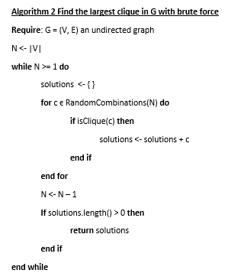

Fig. 2 - Pseudo code to find the largest clique in G

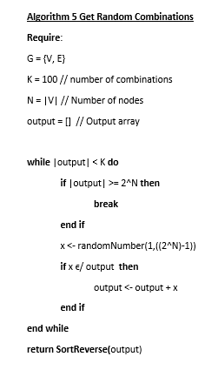
Fig. 4 - Pseudo code to get N random combinations of nodes

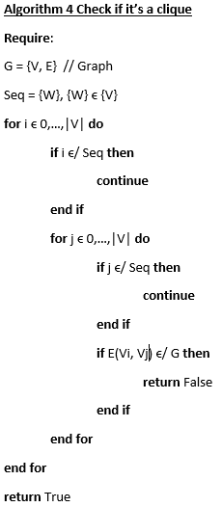
Fig. 3 - Pseudo code to verify if a given combination is a clique of G

Consider a graph G with V vertices and E edges, the algorithm begins by generating K random combinations of G.
After initializing the set of solutions, the algorithm begins to verify each combination.
If no solution was found within the given array of combinations, the algorithm returns 0 solutions.

V. Code Complexity
The algorithm in Figure 2 generates hand load of combinations, followed by a large amount of comparisons in the algorithm in Figure 3.
The code complexity generally uses the big-O notation, exposing the worse case or the worse set of iterations the program will preform.
In this project the complexity of this program is

VII. Important Functions

. Graph Generator
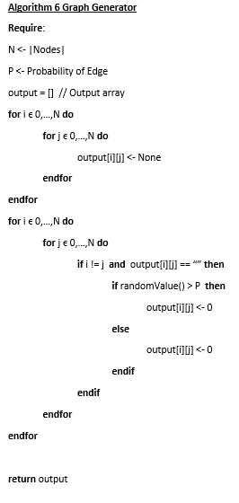

The function generateGraph creates a graph of a given size N of nodes. Edges are later generate with a probability of p, where 1 returns a complete graph and 0 return N isolated nodes.

VIII. Analysis Results

In the previous report [10], there were 3 versions of the exhaustive search algorithm, solving the largest clique of a subgraph. Adjustments were made, showing the first solution encountered, since the combination array is sorted by size, the program will always return the best solution of the array.

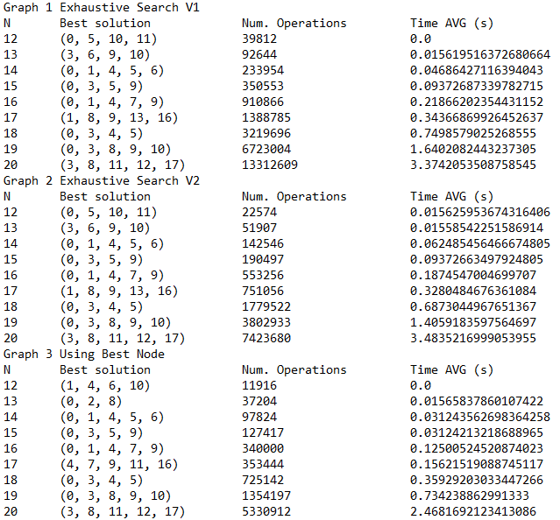
Fig. 6 - Results of previous versions

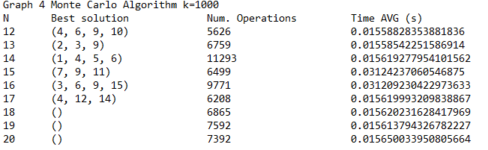
Fig. 5 - Pseudo code to generate a graph

The solutions encountered using the Monte Carlo algorithm, k = 1000, weren’t the best though the processing time was a huge upgrade compared to the exhaustive search results.
Fig. 7 - Monte Carlo results, k=1000
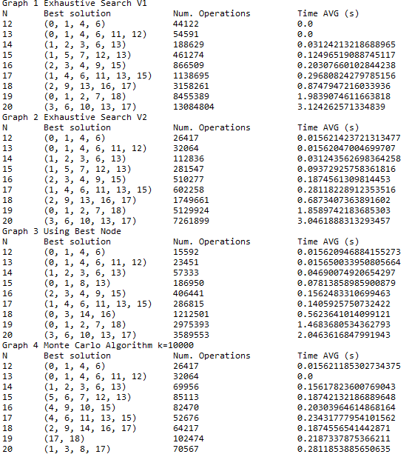

After adjusting k to 10000, the algorithm can properly find solutions for graphs over 18 nodes. The average time also increased proportionally with k.

IX. Conclusion
Probabilistic search, statistically, solves problems much faster than exhaustive search but in contrast, returns low quality or no results. This algorithm is useful in scenarios where there are a lot of factors involved and the best solution is as great as any solution.

VI. Libraries Used

random
the random library [3] implements pseudo-random number generators for various distributions. Most module functions rely on the basic function random(), which returns a random float in a semi-open range [0.0,1.0).
This module was used to generate graphs for testing.

argparse
The argparse library [4] brings a user-friendly handler for command-line interfaces. The application defines arguments which it requires and argparse will parse those out of sys.argv. The argparse module also generates help and usage messages and throws when given invalid arguments.
This module was used to dynamically interact with the script.

matplotlib
The matplotlib library [5] is a python 2d plotting which generates high quality figures in various formats and interactive environments across platforms.
This module was used for to properly compare statistic data.

os
The os library [6] is a portable way in using the operating system dependent functionality.
This module was used to run other scripts.

itertools
The itertools library [7] implements various interator building blocks, a set of fast, memory efficient tools.
This module was used to create combinations of nodes.

time
Fig. 7 – Results of 4 versions, k=10000
The time library [8] provides time-related functions.
This module was used to extract execute time and limit cpu processing.

References
[1] https://en.wikipedia.org/wiki/Brute-force_search
[2] https://en.wikipedia.org/wiki/Clique_(graph_theory)
[3] https://docs.python.org/3/library/random.html
[4] https://docs.python.org/3/library/argparse.html
[5] https://matplotlib.org/
[6] https://docs.python.org/3/library/os.html
[7] https://docs.python.org/2/library/itertools.html
[8] https://docs.python.org/3/library/time.html
[9] https://elearning.ua.pt/pluginfile.php/913972/mod_resource/content/0/AA_08_Intro_Randomized_Algorithms_III.pdf
[10] ./previousReport.pdf

